**ENGR 421**

**Homework 04: Nonparametric Regression**

Deadline: October 12, 2019, 11:59 PM

Sitare Arslantürk, 57677

In this assignment, regressogram, running mean smoother and kernel smoother is implemented via nonparametric regression methods.

The following formulas are calculated in order to find the regressogram

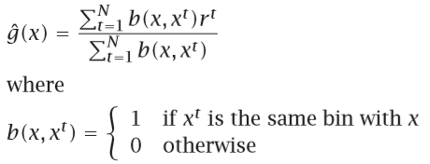

Having discontinuities at bin boundaries is not preferred and to get rid of fixing the origin parameter, the following is used. As the naive estimator, in the running mean smoother, running mean smoother a bin is defined to be symmetric around x and average.

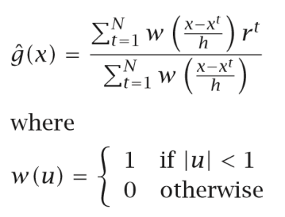

As in the kernel estimator, using a kernel giving less weight to further points, and we get the kernel smoother. A univariate gaussian distribution is used.

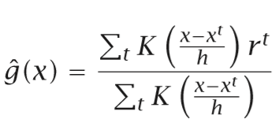

In the end, the root square error for all three methods are calculated and plots are drawn. The root mean squared error is found using,

